**Project Development Phase**

|  |  |
| --- | --- |
| **Date** | 08 November 2022 |
| **Team ID** | PNT2022TMID31571 |
| **Project Name** | Smart Fashion Recommender Application |

**INTEGRATING CHATBOT WITH HTML PAGE (SOURCE CODE):**

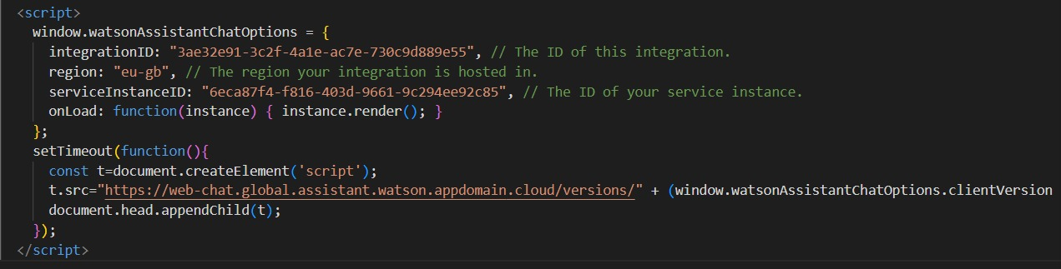

**INTEGRATING CHATBOT WITH HTML PAGE:**

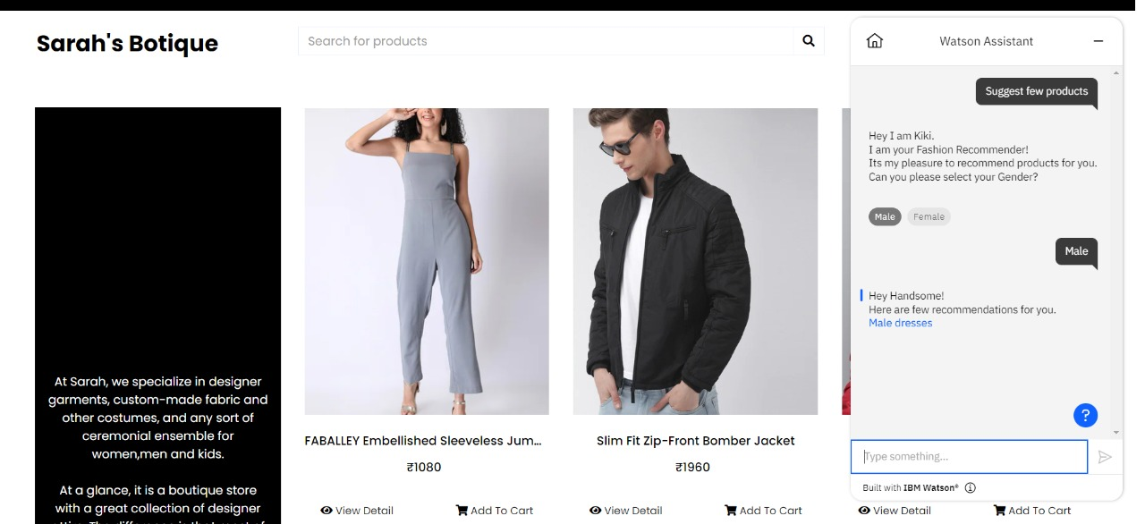

**DOCKER PUSH:**

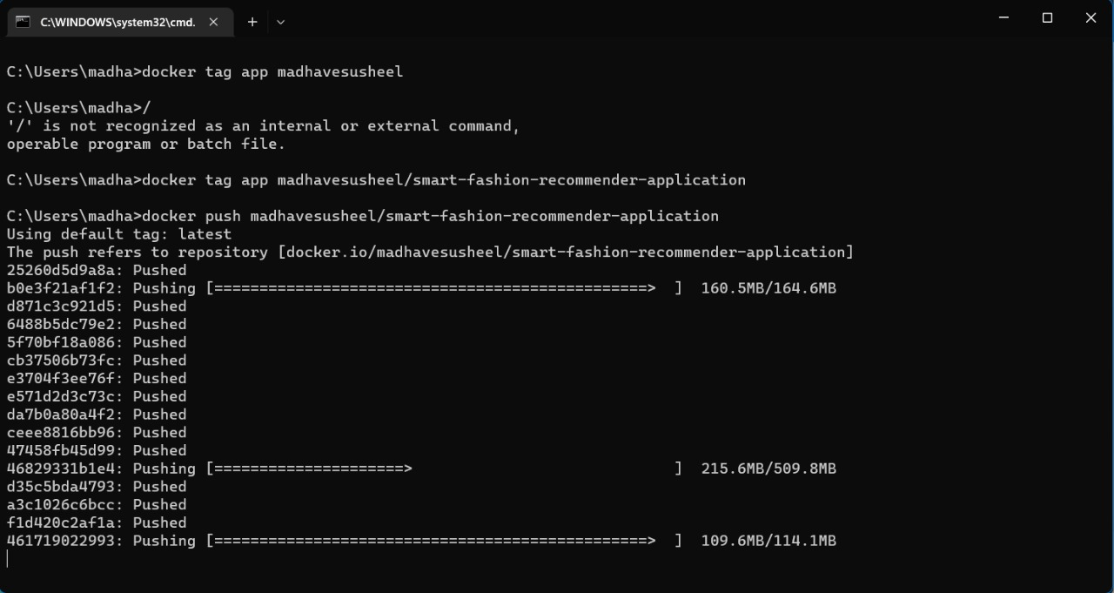

**CONTAINERIZING THE APPLICATION:**

